A VOICE-BASED READING ASSESSMENT SYSTEM FOR ENHANCING THE ARAL READING PROGRAM

A Capstone Project Presented to the Faculty of the

COLLEGE OF INFORMATION TECHNOLOGY
CENTRAL BICOL STATE UNIVERSITY OF AGRICULTURE-SIPOCOT
Sipocot, Camarines Sur

In Partial Fulfillment of the Requirements For the Degree of

BACHELOR OF SCIENCE IN INFORMATION TECHNOLOGY

ANDREW JEFFERSON E. BUENA DIANA MARY ANN D. REJOTO FRANCINE P. TABILOG

May 25, 2026

CHAPTER I

THE PROBLEM AND IT’S BACKGROUND

Introduction

In today’s digital age, technology plays a vital role in enhancing education by providing innovative tools for learning and assessment. The integration of artificial intelligence and voice recognition technologies has enabled more interactive and efficient systems, particularly in language learning and reading assessment. According to Chen et al. (2024) highlighted that speech recognition technology can analyze spoken responses and provide real-time feedback on pronunciation and fluency.
Despite these advancements, many schools still rely on traditional, manual methods of assessing reading performance. Teachers often evaluate students individually by listening, marking errors, and giving feedback, which can be time-consuming and subjective. While effective in small groups, this approach becomes difficult in large classes, limiting the ability to provide consistent and immediate support. As a result, some learners may not receive the timely feedback needed to improve their reading fluency and pronunciation.
Barcelonita Fisheries School, founded on February 8, 1982, is a public secondary school located in Barcelonita, Cabusao, Camarines Sur. It is one of the key educational institutions in the area, providing quality education to both Junior High School and Senior High School students. The school operates under the Department of Education and implements the K–12 curriculum. As of 2022 to the

present, Barcelonita Fisheries School has an approximate student population of

200. The school is currently supervised by Mrs. Nelia Presbitero, Principal I.

Many students struggled with reading fluency and comprehension following the COVID-19 pandemic. Ludewig et al. (2022) reported that disruptions in classroom instruction led to significant learning gaps in reading. Similarly, Kuhfeld, Lewis, and Peltier (2023) found declines in students’ reading performance, with slower progress indicating substantial learning loss due to school closures. Hayati and Puspitaloka (2022) also noted that limited teacher guidance during remote learning made it difficult for students to understand texts independently. These findings are supported by the Stanford Graduate School of Education (2021), which revealed that reading fluency growth nearly stopped during the early stages of the pandemic. As a result, many learners fell behind in essential reading skills due to reduced interaction, limited support, and unequal access to learning resources.
As schools reopened, many learners were found to struggle with expected literacy standards, highlighting the need for structured interventions. In response, the Academic Recovery and Accessible Learning (ARAL) Program, institutionalized through Republic Act No. 12028, was introduced to help learners recover foundational skills in Mathematics, English, and Filipino, particularly in reading and numeracy. However, reading assessments in classrooms remain largely manual and teacher dependent. Tools such as the Philippine Informal Reading Inventory (Phil-IRI) assess learners’ reading abilities based on the number of miscues, reading speed (words per minute), and comprehension

through oral reading tasks, but their one-on-one administration and manual recording make them time-consuming, subjective, and difficult to implement consistently, especially in large classes.
To address these challenges, the proposed study introduces a Voice-Based Reading Assessment System. This system utilizes speech recognition technology through the OpenAi-Whisper Model to capture students’ oral reading, compare spoken words with the expected text, and automatically identify mispronunciations. Errors are computed using a percentage-based scoring system, while results are stored for review. By automating the assessment process, the system reduces teachers’ workload, improves consistency in evaluation, and allows students to monitor and improve their performance independently. Ultimately, this innovation aims to enhance the ARAL Reading Program by combining human instruction with technological efficiency, creating a more objective, scalable, and learner-centered approach to reading assessment.
The core of the system’s speech recognition is powered by the OpenAi-Whisper. This architecture utilizes an encoder-decoder framework to map acoustic features from audio input into a sequence of text tokens via a multi-headed attention mechanism. In this implementation, the system specifically uses the “base” variant of the Whisper model, which provides a balanced trade-off between computational efficiency and transcription accuracy. Because this model is pre-trained on a massive, multilingual corpus, it provides high-accuracy transcription capabilities that are robust enough to handle various speaking styles without the need for additional training or fine-tuning. The evaluation module refines this

transcription through a localized phonetic analysis layer using the Metaphone and Jaro-Winkler algorithms. The Metaphone algorithm reduces spoken words to their consonant-based phonetic roots, allowing the system to prioritize how a word sounds rather than its literal spelling. This is complemented by the Jaro-Winkler similarity algorithm, which measures the lexical distance between the transcription and the reference text. Together, these provide a dual-layered assessment that distinguishes between actual reading errors and common local accent variations, such as phoneme substitutions. By integrating this rule-based phonetic alignment with a pre-trained "zero-shot" transformer model, the research eliminates the requirement for gathering and labeling a custom local dataset. The system leverages the extensive linguistic knowledge already present in the Whisper model to achieve high-accuracy results immediately. This approach ensures technical feasibility and resource efficiency, as it bypasses the extensive time and data constraints typically associated with custom machine learning development. To maintain this efficiency during live use, the system is hosted on a Hostinger VPS. This dedicated environment provides the necessary throughput for the 'base' Whisper model to process audio input in near real-time, bridging the gap between heavy AI computation and a responsive user experience. The Jaro-Winkler algorithm offers several strengths in this context. It is particularly effective for short strings such as words, making it well-suited for word-level comparison in reading assessment. Its prefix weighting mechanism gives higher similarity scores to strings that match at the beginning, which aligns well with how humans perceive word similarity. Additionally, it is computationally efficient, allowing for real-time

evaluation. However, the algorithm also has limitations. It is less effective for longer strings or full sentences, as it does not account for semantic meaning or contextual relationships between words. It may also overemphasize prefix similarity, potentially giving high scores to words that start similarly but differ significantly in meaning. Furthermore, it operates purely at the character level, making it insensitive to deeper phonetic nuances beyond what is captured by the complementary Metaphone algorithm.

Objectives

The main objective of this study is to develop a web-based voice reading assessment system that supports the implementation of the ARAL Reading Program. Specifically, this study aims to:
- Utilize a questionnaire module for pre-assessment and post-assessment to evaluate students’ baseline performance and learning progress.
- Implement a student selection and profiling system for the ARAL Program, to enable efficient identification, classification, and data management of learners.
- Evaluate students’ reading fluency and pronunciation accuracy through a voice-based assessment using the OpenAi-Whisper model.
- Develop a recommendation system based on the Philippine Informal Reading Inventory (Phil-IRI) results that provides targeted interventions and reading development strategies according to students’ reading performance and academic progress.

Scope and Delimitations

This study focuses on the development of a Web Voice-Based Reading Assessment System intended to strengthen the implementation of the ARAL Reading Program. The scope of the research covers selected students from Grades 7 to 10 who are still struggling to read fluently and accurately. These learners will serve as the main participants since the system is designed to provide real-time evaluation of reading fluency, pronunciation, and comprehension, which directly supports the objectives of the ARAL program.
On the other hand, the study is delimited to exclude students who are not part of the ARAL Reading Program and those who can already read proficiently. Since the purpose of the system is to assist struggling readers, learners who have already achieved satisfactory reading skills are not included in the research.
Furthermore, the ARAL Program includes three learning areas: Mathematics, English, and Filipino. However, this study is limited to the English component of the program, as the developed system focuses on assessing English reading performance. Therefore, the Mathematics and Filipino components of the ARAL Program are excluded from the scope of this study. This delimitation ensures that the research remains focused on improving students’ English reading skills and aligns with the purpose of the voice-based reading assessment system.

Significance of the Study

This study aims to enhance the effectiveness of the ARAL Reading Program through technology-driven solutions that provide real-time evaluation of learners’

reading performance based on the number of miscues, reading speed (words per minute), and comprehension. By addressing the limitations of traditional assessment methods, it seeks to support teachers in monitoring student progress more efficiently and empower learners with immediate feedback to strengthen their reading skills. Essentially, this study may benefit the following:
Barcelonita Fisheries School. The implementation of the system can strengthen the ARAL Reading Program within the institution. It may promote innovation in literacy development and highlight the school’s commitment to adopting modern approaches in addressing learning challenges.
Teachers. The system can serve as a reliable tool to monitor students’ reading progress more efficiently. It may help teachers identify learners who need additional support and provide timely interventions to improve reading performance.
Students. With the help of this system, struggling readers can receive immediate feedback on their reading skills. This may boost their confidence, encourage active participation in the ARAL program, and gradually improve their fluency and comprehension.
Future Researchers. The findings of this study may serve as a reference for future research in educational technology, literacy assessment, and program improvement, contributing to the advancement of knowledge in the field.

Conceptual Framework

Figure 1.1 represents the conceptual framework of the Voice-Based Reading Assessment System for Enhancing the ARAL Reading Program.









The framework follows the Input–Process–Output (IPO) model of system analysis and design, as well as describes the structure of the information processing of the proposed system.
•

•
Input
Student Profile Data
Reading Passage Student Voice Recording Comprehension Assessment
Items
•
•
•
•
•
•
Process
Speech Recognition (OpenAi-Whisper) Text Comparison (WER/WPM/ ACCURACY)
Phil-IRI-Based Reading Performance Analysis and Intervention Recommendation Feedback Generation
Output
- A Voice-Based Reading Assessment System for enhancing the ARAL
Reading Program
FEEDBACK

Figure 1.1

Conceptual Framework of a Voice-Based Reading Assessment System for Enhancing the ARAL Reading Program
As illustrated in the conceptual framework, the system begins with the input stage, where essential data such as student information, reading passages, and voice recordings are collected. The student must first provide their details and

select or be assigned a reading text. Once the recording starts, the system captures the learner’s spoken output while reading aloud.
In the process stage, the system utilizes speech recognition technology, specifically the OpenAi-Whisper model, to convert the recorded speech into text. This output is then compared with the original passage using text comparison metrics such as Word Error Rate (WER), Words Per Minute (WPM), and overall accuracy. Based on these measurements, the system evaluates the student’s reading fluency and pronunciation. The system then analyzes the learner’s reading performance based on the Philippine Informal Reading Inventory (Phil-IRI) results and generates appropriate reading intervention recommendations. Following this, the system generates appropriate feedback to guide the student.
Finally, in the output stage, the system produces a voice-based reading assessment designed to enhance the ARAL Reading Program. The results, including performance scores and feedback, are presented to both students and teachers. Additionally, the framework incorporates a feedback loop, where the generated feedback is used to support continuous improvement. This allows students to practice further, refine their reading skills, and progressively improve their fluency, comprehension, and overall reading ability.

Definition of Terms

The following terms are used in this study. For easy and better understanding, these are defined conceptually and operationally.

ARAL Reading Program. “This refers to the nationwide initiative of the Department of Education aimed at strengthening literacy and improving students’ reading comprehension and fluency.” In this study, this pertains to the program implemented at Homobono H. Gonzalez National High School where the voice-based assessment system will be applied to support struggling readers.
Artificial Intelligence. “This refers to the ability of a computer or computer-controlled system to perform tasks that are normally associated with human intelligence, such as reasoning, learning, and problem-solving.” In this study, this pertains to the technology used to analyze students’ spoken reading and assist in evaluating pronunciation and fluency.
Comprehension. “This refers to the ability to understand and interpret the meaning of written text.” In this study, this pertains to the broader goal of the ARAL Reading Program, which the system indirectly supports by improving fluency and pronunciation.
Jaro-Winkler Algorithm. “This refers to a string similarity algorithm that measures the closeness between two text strings, giving higher importance to matching characters at the beginning of the words.” In this study, this pertains to the technique used to evaluate the similarity between the student’s spoken response and the expected word or sentence.
Metaphone Algorithm. “This refers to a phonetic algorithm used to encode words based on their pronunciation rather than their spelling.” In this study, this pertains

to the method used to compare spoken words with the correct pronunciation by identifying similarities in sound patterns.
OpenAI Whisper. “This refers to an automatic speech recognition (ASR) model developed by OpenAI that converts spoken language into text through artificial intelligence and deep learning techniques.” In this study, this pertains to the voice-based assessment tool used to evaluate students’ oral reading fluency, pronunciation accuracy, and reading performance by transcribing and analyzing learners’ spoken responses.
Pronunciation. “This refers to the way in which words are spoken.” In this study, this pertains to the accuracy of learners in producing sounds and words correctly while reading aloud.
Reading Fluency. “This refers to the ability to read text accurately, quickly, and with proper expression.” In this study, this pertains to the skill being measured by the system to determine how well students can read aloud with accuracy and speed.
Real-Time Feedback. “This refers to instructional responses or evaluations provided immediately after a learner’s action, allowing rapid identification of errors and supporting adaptive learning in digital systems.” In this study, this pertains to the instant feedback given by the voice-based reading assessment system to students regarding pronunciation, fluency, and reading performance.
Speech-to-Text. “This refers to a computerized process that converts spoken language into written text using speech recognition technology.” In this study, this

pertains to the process used by the system to transcribe students’ spoken reading into text for analysis and evaluation.
Voice Recognition. “This refers to a technology that allows a computer system to identify and process human speech and convert it into text or commands.” In this study, it pertains to the feature of the proposed system that analyzes students’ spoken reading and detects pronunciation errors.
Zero-shot. “A prompt engineering method that relies on the pretraining of a large language model (LLM) to infer an appropriate response without being given examples of the desired output. Unlike few-shot prompting, zero-shot prompting does not provide sample responses within the prompt and instead depends on the model’s existing knowledge and learned patterns from training.”

NOTES

Chen, Y. C., Chen, N. S., & Lin, Y. T. (2024). Integrating artificial intelligence and extended reality in language education: A systematic literature review (2017–2024). Education Sciences, 15(8), 1066. Retrieved from https://doi
.org/10.3390/educsci15081066

Ludewig, U., Kleinkorres, R., Schaufelberger, R., & McElvany, N. (2022). The COVID-19 pandemic and student achievement in reading: A longitudinal analysis. Frontiers in Psychology, 13, 876485. Retrieved from https
://doi.org/10.3389/fpsyg.2022.876485

Kuhfeld, M., Lewis, K., & Peltier, T. (2023). Reading achievement declines during the COVID-19 pandemic: Evidence from 5 million U.S. students. Educational Researcher. Retrieved from https://doi.org/10.3102/00 13189X231153112

Hayati, H. A., & Puspitaloka, N. (2022). An analysis of students’ reading comprehension difficulties during the COVID-19 pandemic. Journal of English Teaching, 8(2), 123–134. Retrieved from https://www.researchgate
.net/publication/364464529

Stanford Graduate School of Education. (2021). New Stanford study sheds light on how much learning young students have lost during stages of the pandemic. Retrieved from https://ed.stanford.edu/news/new-stanford-study-sheds-light-how-much-learning-young-students-have-lost-during-stages

Department of Education. (2024). Academic Recovery and Accessible Learning (ARAL) Program. Retrieved from https://elibrary.judiciary.gov.ph/thebook shelf/showdocs/2/97912

IBM. (n.d.). What is artificial intelligence (AI)? IBM. Retrieved March 5, 2026, from https://www.ibm.com/think/topics/artificial-intelligence

Cambridge University Press & Assessment. (n.d.). Comprehension. Cambridge Dictionary. Retrieved March 5, 2026, from https://dictionary.cambridge
.org/dictionary/english/comprehension\

Power, D. J. (2007). A brief history of decision support systems. DSSResources.COM. Retrieved from http://dssresources.com/history
/dsshistory.html

Systran. (2023). Faster-Whisper: Reimplementation of OpenAI's Whisper model using CTranslate2. GitHub. Retrieved from https://github.com/SYSTRAN/ faster-whisper

GeeksforGeeks. (2025). Jaro and Jaro-Winkler similarity. Retrieved from https://www.geeksforgeeks.org/jaro-and-jaro-winkler-similarity/

TiloRes. (n.d.). Metaphone phonetic algorithm online tool. Retrieved March 5, 2026, from https://tilores.io/metaphone-phonetic-algorithm-online-tool

Khalilov, V. (2022). OpenAI Whisper Your speech-to-text AI: History and usage. SuperAnnotate. Retrieved from https://www.superannotate.com /blog
/openai-whisper-automatic-speech-recognition-system

Cambridge University Press & Assessment. (n.d.). Pronunciation. Cambridge Dictionary. Retrieved March 5, 2026, from https://dictionary.cambridge
.org/dictionary/english/pronunciation

E., Johnson, J., & William, B. (2025). Real-Time Feedback Systems in Assistive E-Learning: A Step Toward Inclusive Education. ResearchGate. Retrieved from https://www.researchgate.net/publication/389891863_RealTime_Fee dback_Systems_in_Assistive_E_Learning_A_Step_Toward_Inclusive_Ed ucation

Hu, C., & Downie, A. (n.d.). What is speech-to-text? IBM Think. Retrieved March 5, 2026, from https://www.ibm.com/think/topics/speech-to-text

Cambridge University Press & Assessment. (n.d.). Voice recognition. Cambridge Dictionary. Retrieved March 5, 2026, from https://dictionary.cambridge. org/dictionary/english/voice-recognition

IBM. (n.d.). What is zero-shot learning? IBM. Retrieved March 5, 2026, from https://www.ibm.com/think/topics/zero-shot-learning

CHAPTER II

REVIEW OF RELATED LITERATURE AND STUDIES

This chapter reviews the related literature and studies gathered from the internet, journals, and books. All serve as supporting evidence to this research study.

Questionnaire Module for Pre-Assessment and Post-Assessment

Assessment systems are important tools in evaluating students’ learning progress and determining the effectiveness of instructional strategies. According to Heydarnejad, Tagavipour, and Patra (2022), assessment systems help educators monitor learners’ comprehension, motivation, and academic performance through continuous evaluation. Their study explained that performance-based assessments improve the reliability of educational evaluation and support data-driven instruction. The researchers further emphasized that assessment activities provide meaningful feedback that can guide teachers in identifying learners who require additional academic support and intervention.
Similarly, Cooksey and Jonsson (2022) stated that pre-test and post-test questionnaires are essential in curriculum development because they determine students’ baseline knowledge and measure learning gains after instruction. Their findings highlighted that structured quizzes and assessment forms enable educators to evaluate teaching effectiveness and learner improvement systematically. The researchers also emphasized that assessment results can support educational planning and improve the implementation of instructional programs.

In another study, Ritonga, Tazik, and Omar (2022) explained that assessment activities positively influence reading comprehension, vocabulary learning, and learner motivation. Their research revealed that consistent evaluation practices encourage active participation in learning activities and improve students’ academic confidence. The study highlighted that educational assessments help teachers understand students’ learning behaviors and provide opportunities for continuous learner development.
Furthermore, Abdulaal, Alenazi, Tajuddin, and Hamidi (2022) found that diagnostic assessments positively influence students’ speaking fluency and accuracy. Their findings showed that educational assessment systems provide important feedback that assists teachers in identifying learners’ weaknesses and creating appropriate interventions to improve academic performance. The researchers emphasized that diagnostic assessments are effective tools for monitoring students’ progress before and after instruction. The importance of digital educational systems was also discussed by Kwon, Kim, Bae, Cho, Lee, and Dreamson (2021), who explained that learning management systems and educational technologies improve the monitoring of student performance and the management of learner information. Their study highlighted that digital educational systems support efficient student assessment, facilitate data organization, and improve accessibility to academic records. These technologies also assist educators in making informed decisions regarding instructional strategies and learner development.

These studies highlight the significance of utilizing assessment systems in evaluating students’ baseline performance and learning progress. The reviewed literature suggests that pre-assessment and post-assessment tools provide reliable data that can support instructional improvement, learner monitoring, and intervention planning. In relation to the present study, the use of a questionnaire module for pre-assessment and post-assessment will help evaluate students’ academic performance before and after participation in the ARAL Program, enabling educators to measure learning progress and determine the effectiveness of reading interventions.

Student Selection and Profiling System

Student profiling systems play an important role in organizing learner information and improving educational management. According to Kwon, Kim, Bae, Cho, Lee, and Dreamson (2021), learning management systems help educational institutions collect, organize, and manage student data effectively. Their study emphasized that digital systems support personalized learning and improve communication between teachers and learners through organized learner records and performance monitoring. The researchers further explained that technology-based systems improve the efficiency of educational processes by making student information more accessible and manageable.
Recent educational technologies have also integrated profiling systems to classify learners according to their academic needs and performance. Kwon et al. (2021) explained that digital systems improve learner management and help educators monitor students’ educational progress using organized databases.

Through these systems, educators can easily identify learners who require academic support and implement suitable interventions according to students’ needs. Similarly, Cooksey and Jonsson (2022) stated that learner data gathered through assessments can be used to identify academic strengths and weaknesses. Their study emphasized that systematic student profiling supports educational planning and targeted intervention programs because educators are provided with reliable information regarding students’ academic conditions. The researchers also highlighted that organized learner data contributes to more effective instructional planning and student monitoring.
Heydarnejad, Tagavipour, and Patra (2022) further explained that assessment-based learner classification helps teachers develop appropriate instructional strategies according to students’ needs and abilities. Their findings showed that educational technologies improve the accessibility of academic records and learner evaluations, making it easier for teachers to monitor students’ performance and identify areas requiring improvement. The study emphasized that learner classification is important in ensuring that instructional interventions are aligned with students’ learning capacities.
In another study, Ritonga, Tazik, and Omar (2022) found that digital assessment systems improve learners’ engagement and academic monitoring. The researchers explained that technology-based educational systems provide accurate learner information that assists educators in making informed decisions regarding student development and intervention planning. These systems also

support efficient monitoring of students’ academic progress and participation in learning activities.
These studies highlight the importance of implementing student profiling systems in educational programs and assessment systems. Understanding learners’ academic profiles, strengths, and weaknesses allows educators to design appropriate instructional strategies and interventions that respond to students’ needs. In relation to the present study, the implementation of a student selection and profiling system for the ARAL Program will support efficient learner classification, organized data management, and effective monitoring of students’ academic progress.

Voice-Based Assessment Using OpenAI Whisper

Voice-based assessment systems have become widely used in evaluating reading fluency and pronunciation accuracy. According to Molenaar, Tejedor-Garcia, Strik, and Cucchiarini (2023), automatic speech recognition systems such as Whisper can effectively assess oral reading accuracy and support reading diagnostics. Their findings showed that AI-based speech recognition technologies achieved results comparable to human evaluation in assessing students’ oral reading performance. The researchers emphasized that automated systems provide reliable and efficient tools for evaluating learners’ reading abilities and identifying reading difficulties.
Similarly, Wang et al. (2022) explained that automatic assessment systems for oral reading can evaluate reading fluency, pronunciation, and expressiveness

through speech-based analysis. Their study revealed that speech recognition technologies support educators in monitoring reading development more efficiently by providing objective and accurate assessment results. The researchers also noted that automated oral reading systems help reduce the time and effort required in traditional reading evaluations.
In another study, Inceoglu, Chen, and Lim (2022) examined the use of automatic speech recognition in pronunciation assessment. Their findings showed that ASR systems support pronunciation learning by providing feedback regarding learners’ intelligibility and speaking performance. The study emphasized that speech recognition technologies improve pronunciation evaluation because they can analyze speech patterns consistently and accurately. Kim, Jeon, Seo, and Kim (2022) also introduced an automatic pronunciation assessment system using self-supervised speech representation learning. Their research demonstrated that AI-based pronunciation evaluation systems improve the accuracy of assessing learners’ pronunciation skills and speaking performance. The researchers explained that advanced speech recognition models contribute to more reliable language assessment systems that can support educational applications.
Furthermore, Saito, Macmillan, Kachlicka, Kunihara, and Minematsu (2022) discussed automated assessment systems for second-language comprehensibility. Their study emphasized that AI-driven speech assessment tools are effective in evaluating fluency, pronunciation, and oral communication skills in educational environments. The researchers further explained that automated

speech assessment systems provide consistent feedback that can support learners in improving their oral reading and speaking abilities.
These studies highlight the importance of utilizing voice-based assessment technologies in evaluating reading fluency and pronunciation accuracy. The reviewed literature suggests that automatic speech recognition systems provide reliable, efficient, and objective assessment results that can support reading diagnostics and intervention planning. In relation to the present study, the implementation of a voice-based assessment using the OpenAI Whisper model will help evaluate students’ oral reading performance and support the development of appropriate literacy interventions for struggling readers.

Recommendation System Based on Phil-IRI Results

Recommendation systems are important tools in providing targeted interventions and reading development strategies for struggling readers. According to Heydarnejad, Tagavipour, and Patra (2022), assessment-based educational interventions improve students’ reading comprehension and academic performance by identifying learners’ needs through diagnostic evaluations. Their findings emphasized that intervention strategies based on assessment results help educators address students’ specific learning difficulties and improve overall academic achievement.
Similarly, Ritonga, Tazik, and Omar (2022) explained that learner-centered interventions improve reading motivation and vocabulary development by addressing students’ individual learning needs. Their study highlighted that

educational recommendation systems can support individualized learning strategies for students with different reading abilities. The researchers further explained that targeted instructional interventions contribute to better learner engagement and academic improvement.
Molenaar, Tejedor-Garcia, Strik, and Cucchiarini (2023) also emphasized that automated reading assessments provide reliable information that can be used to design targeted reading interventions and support systems for learners experiencing reading difficulties. Their study revealed that assessment-based intervention planning improves the efficiency of literacy programs because educators can identify students’ reading challenges more accurately. In another study, Wang et al. (2022) found that oral reading assessment systems can identify students’ fluency and pronunciation difficulties, allowing educators to provide suitable reading development strategies and intervention programs. Their findings showed that speech-based assessment technologies help educators monitor learners’ reading performance and implement appropriate literacy support according to students’ needs.
Furthermore, Cooksey and Jonsson (2022) stated that assessment results should be used to improve curriculum planning and provide evidence-based recommendations for learner development. Their study emphasized that educational recommendation systems support continuous student improvement through data-driven instructional strategies and intervention planning. The researchers highlighted that assessment-based recommendations help educators provide more effective learning experiences for students.

These studies highlight the importance of implementing recommendation systems in literacy programs and educational assessment systems. The reviewed literature suggests that assessment-based interventions and recommendation systems support individualized learning, improve reading development, and assist educators in addressing learners’ specific academic needs. In relation to the present study, the development of a recommendation system based on Phil-IRI results will help provide targeted interventions and reading development strategies according to students’ reading performance and academic progress.

Synthesis of Related Literature and Studies

The reviewed literature highlights the importance of assessment systems, student profiling, voice-based reading evaluation, and recommendation systems in improving literacy programs and educational interventions. Studies by Heydarnejad et al. (2022), Cooksey and Jonsson (2022), Ritonga et al. (2022), Abdulaal et al. (2022), and Kwon et al. (2021) emphasized that pre-assessment and post-assessment tools are essential in monitoring students’ learning progress, identifying academic strengths and weaknesses, and evaluating the effectiveness of instructional strategies. These studies revealed that continuous assessment practices support data-driven instruction, improve learner engagement, and provide educators with reliable information necessary for intervention planning and academic monitoring.
The literature also emphasized the significance of student selection and profiling systems in educational management. Kwon et al. (2021) explained that digital educational technologies and learning management systems improve the

organization, accessibility, and management of learner information. Similarly, Cooksey and Jonsson (2022), Heydarnejad et al. (2022), and Ritonga et al. (2022) highlighted that systematic learner profiling supports effective instructional planning, targeted interventions, and efficient academic monitoring. These studies suggest that profiling learners according to their academic needs and performance allows educators to develop more personalized and appropriate instructional strategies for students.
Advancements in artificial intelligence and speech recognition technologies further support the development of voice-based assessment systems for literacy evaluation. Molenaar et al. (2023), Wang et al. (2022), Inceoglu et al. (2022), Kim et al. (2022), and Saito et al. (2022) emphasized that automatic speech recognition systems such as OpenAI Whisper can effectively assess oral reading fluency, pronunciation accuracy, and oral communication skills. Their studies demonstrated that AI-driven speech assessment tools provide objective, reliable, and efficient evaluation results comparable to human assessment. These technologies also improve reading diagnostics and support educators in identifying students’ reading difficulties more efficiently.
The reviewed studies also highlighted the importance of recommendation systems and targeted interventions in supporting struggling readers. Heydarnejad et al. (2022) and Ritonga et al. (2022) emphasized that assessment-based educational interventions improve reading comprehension, vocabulary development, and learner motivation by addressing students’ specific academic needs. Similarly, Molenaar et al. (2023) and Wang et al. (2022) explained that

automated reading assessments provide reliable information that can be used to design suitable literacy interventions and reading development strategies. Cooksey and Jonsson (2022) further emphasized that assessment results should be utilized in developing evidence-based instructional recommendations that support continuous learner improvement and curriculum planning.
Overall, the reviewed literature converges on the importance of integrating assessment systems, student profiling, speech recognition technologies, and recommendation systems in literacy programs and educational interventions. The studies collectively suggest that combining pre-assessment and post-assessment tools, learner profiling, AI-based oral reading evaluation, and intervention recommendation systems provides a comprehensive framework for monitoring students’ progress and supporting struggling readers. In relation to the present study, these findings support the development of a voice-based reading assessment and recommendation system for the ARAL Program that aims to improve learner assessment, academic monitoring, and literacy intervention planning through the use of educational technologies and artificial intelligence.

NOTES

Heydarnejad, T., Tagavipour, F., & Patra, I. (2022). The impacts of performance-based assessment on reading comprehension achievement, academic motivation, foreign language anxiety, and students’ self-efficacy. Language Testing in Asia, 12(51). Retrieved from https://link.springer. com/article/10.1186/s40468-022-00202-4

Cooksey, K. L., & Jonsson, P. (2022). Using pre-/post-quizzes intentionally in curriculum development and evaluation. Retrieved from https://arxiv
.org/abs/2210.01823

Ritonga, M., Tazik, K., & Omar, A. (2022). Assessment and language improvement: The effect of peer assessment on reading comprehension, reading motivation, and vocabulary learning among EFL learners. Language Testing in Asia, 12(36). Retrieved from https://link.springer.com/article
/10.1186/s40468-022-00188-z

Abdulaal, M. A. A., Alenazi, M. H., Tajuddin, A. J. A., & Hamidi, B. (2022). Dynamic vs. diagnostic assessment: Impacts on EFL learners’ speaking fluency and accuracy, learning anxiety, and cognitive load. Language Testing in Asia,
12(32). Retrieved from https://link.springer.com/article/10.1186/s40468-022-00179-0

Kwon, S., Kim, W., Bae, C., Cho, M., Lee, S., & Dreamson, N. (2021). The identity changes in online learning and teaching: Instructors, learners, and learning management systems. International Journal of Educational Technology in Higher Education, 18(67). Retrieved from https://link.springer.com/article
/10.1186/s41239-021-00304-8
Molenaar, B., Tejedor-Garcia, C., Strik, H., & Cucchiarini, C. (2023). Automatic assessment of oral reading accuracy for reading diagnostics. Retrieved from https://arxiv.org/abs/2306.03444

Wang, F., et al. (2022). Automatic assessment of oral readings of young pupils. Speech Communication, 138, 67–79. Retrieved from https://www. sciencedirect.com/science/article/pii/S0167639322000164

Inceoglu, S., Chen, W.-H., & Lim, H. (2022). Assessment of L2 intelligibility: Comparing L1 listeners and automatic speech recognition. ReCALL. Retrieved from https://www.cambridge.org/core/ journals/recall/article
/abs/assessment-of-l2-intelligibility-comparing-l1-listeners-and-automatic-speech-recognition/7E499AD990383AC65A9688BB5BE17887

Kim, E., Jeon, J.-J., Seo, H., & Kim, H. (2022). Automatic pronunciation assessment using self-supervised speech representation learning. Retrieved from https://arxiv.org/abs/2204.03863

Saito, K., Macmillan, K., Kachlicka, M., Kunihara, T., & Minematsu, N. (2022). Automated assessment of second language comprehensibility: Review, training, validation, and generalization studies. Studies in Second Language Acquisition. Retrieved from https://www.cambridge.org/core
/journals/studies-in-second-language-acquisition/article /automat ed-assessment-of-second-language-comprehensibility-review-training-vali dation-and-generalization-studies/ED850D916818C7ABA23EA1CA8CF 8A590

CHAPTER III
RESEARCH DESIGN AND METHODOLOGY

This chapter presents the research design, methodology, system architecture, requirements, and diagrams for the system “a voice-based reading assessment system for enhancing the aral reading program”.

Research Design

This study adopted both developmental and descriptive methods of research to achieve its objectives. The descriptive method was employed to gather information by observing and documenting the reading behaviors of students enrolled in the ARAL Program. Through this approach, data on reading fluency, pronunciation accuracy, and comprehension levels were collected, providing insights into the current challenges faced by learners and guiding the formulation of appropriate solutions. Meanwhile, the developmental method was applied in the design and creation of a voice-based reading assessment system. This process involved establishing a business case that led to the development of a software product capable of monitoring and evaluating students’ oral reading performance. The system allowed teachers to record and analyze reading outputs, generate reports, and provide timely feedback, while also enabling users to access information about reading progress and areas needing improvement.
By combining descriptive observations with developmental processes, and grounding the study in relevant literature, the researchers ensured that the project was both researchable and responsive to the needs of the ARAL Reading Program.

Research Methodology

The Iterative SDLC model was used in developing the system. It explains and illustrates the processes and procedures of the project plan and establishment phase. It refers to a development life cycle designed to deliver high-quality systems through repeated cycles of planning, design, implementation, and testing (Larman & Basili, 2003).
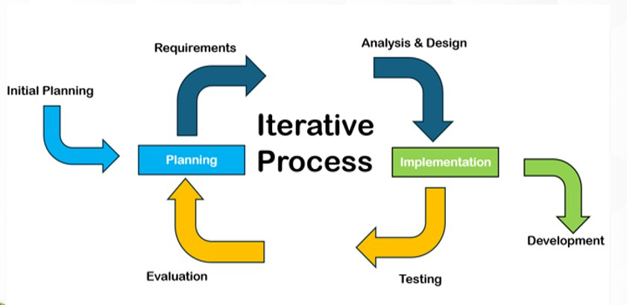
Literature about the Iterative model centers on incremental development and user involvement, where analysis, design, build, and test phases are repeated in short cycles until the system evolves into its final form. Each iteration produces a working prototype that incorporates feedback from stakeholders, allowing requirements to be refined and risks to be reduced. This set of methods was developed to overcome the weaknesses of traditional system development methods by emphasizing adaptability, continuous improvement, and early delivery of functional components. Compared to traditional approaches, the Iterative model provides flexibility and better alignment with user needs (Kumar & Bhatia, 2014).
Figure 3.1

Iterative Model

Phase 1: Initial Planning/Planning

In this phase, the researchers worked together with stakeholders to set the goals and expectations of the project based on the challenges observed in students’ reading performance. They conducted informal consultations and observations with teachers involved in the ARAL Reading Program to better understand common difficulties in fluency, pronunciation, and comprehension. At the same time, the researchers planned the tasks, timeline, and resources needed for the system’s development, including the tools and methods to be used. This phase aimed to ensure that the project was well-organized and could be carried out smoothly and efficiently.

Phase 2: System Requirements

In this phase, the developers and program coordinators collaborated in determining the goals and expectations of the project given the current and potential issues in the ARAL Reading Program. For this purpose, the researchers conducted both structured and unstructured interviews with teachers and reading coordinators at Barcelonita Fisheries School. Its aim was to gather information and identify all encountered problems in assessing students’ oral reading fluency and comprehension.
Based on the data gathered, it was found that teachers experienced difficulties in conducting manual reading assessments, particularly in terms of consistency, time consumption, and subjectivity of scoring.

Furthermore, teachers had limited tools to analyze pronunciation errors, pacing, and comprehension levels in real time. Experience and informal strategies, such as relying on classroom observations usually used in determining reading performance. These led to issues on credibility and reliability of the assessment results. After assessing the problems of the client (teachers and students), the researchers decided to develop a voice-based reading assessment system that is able to record, analyze, and provide feedback on students’ oral reading performance.
Table 3.1

Software Requirements

 | Minimum | Recommended
Operating System | Windows 7 | Ubuntu
Browser | Any browser | Google Chrome
Programming Language | Php, Python,
Database | MySQL, SQL Server

Table 3.1 shows the software requirements for the system to properly and efficiently work. These requirements are based on the studies and developers who used the same algorithm.
Table 3.2

Hardware Requirements
 | Minimum | Recommended
Processor | Intel Core i3 | Intel Core i7
Memory | 500 GB | 1 TB
RAM | 8 GB | 16 GB

Hardware requirements are important to utilize the system. Hardware was defined as the physical components that a computer system is required for the system to function. Table 3.2 shows the hardware requirements. The system

requires Intel Core i3 or a higher version of processor, the storage should have at least 500 GB as the minimum, but 1 TB is the recommended capacity. The RAM should be at least 8 GB but 16 GB is the recommended capacity.
Moreover, the researchers developed a Gantt chart (Figure 3.2) to serve as a guide in monitoring the progress of the project. This chart functioned as an essential project management tool that helped organize and present the entire project timeline in a clear and structured manner. It showed the different tasks and milestones, along with their corresponding schedules for each phase of the study.
Through this visual guide, the researchers were able to manage resources more effectively, anticipate possible delays, and maintain a steady flow of activities. As the project progressed, the Gantt chart also acted as a reference for comparing actual accomplishments with the planned timeline, making it an important tool in ensuring the successful completion of the study.

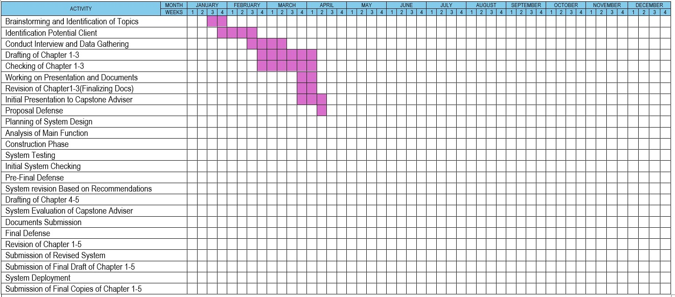
Figure 3.2

Gantt chart of a Voice-based reading assessment system for enhancing the Aral reading program

Phase 3: Analysis and Design


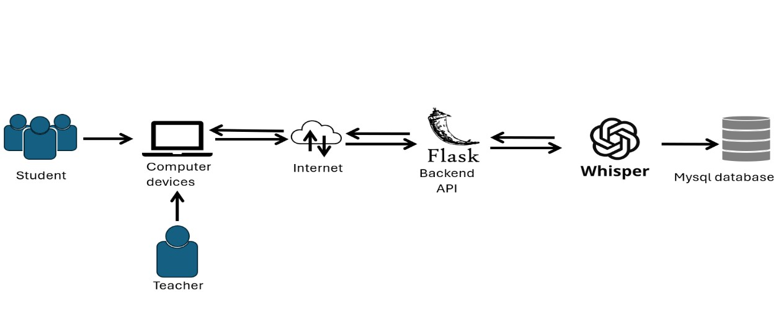
During this phase, the systems architecture determines the component’s interfaces and behavior. Requirements or data were transformed into designs, which are then used to develop the system interface. This phase contains the flow's main diagram and acts as a blueprint and basis for creating the system structure.
Figure 3.3

System Architecture of a Voice-based reading assessment system for enhancing the Aral reading program
Figure 3.3 illustrates how the different components of the system interact with each other. The system involves two main users: the student and the teacher, who both access the platform using computer devices. These devices are connected to the internet, which serves as the communication link between the users and the system. Through the internet, requests are sent to the backend API developed using Flask, which processes the data and handles the system’s logic. The backend then communicates with the OpenAi-Whisper to process speech-related tasks, such as recognizing and analyzing the student’s reading input. After

processing, the data is stored in the MySQL database, where it can be saved and retrieved when needed.
After creating the system architecture diagram, the researchers crafted the Data Flow Diagram (DFD) of the project. This diagram is important as it helps clearly identify and explain the different processes involved in the system, particularly how data moves from input to storage and eventually to report generation. In this phase, the researchers initially developed the Level 0 (Context Diagram) followed by the Level 1 DFDs to provide a more detailed representation
of the system’s processes.
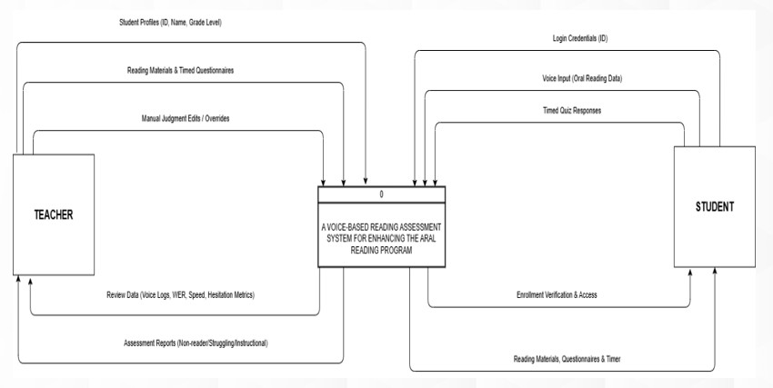

Figure 3.4

Context Diagram of a Voice-based reading assessment system for enhancing the Aral reading program

Figure 3.4 shows the context diagram of the Voice-Based Reading Assessment System for Enhancing the ARAL Reading Program, highlighting the interaction between two main external entities: the teacher and the student.

The student first provides their login credentials (ID) to access the system. Once authenticated, the system allows the student to participate in reading activities by accessing reading materials, questionnaires, and a timer. During the assessment, the student submits voice input (oral reading data) and answers timed quiz responses. These inputs are processed by the system to evaluate the student’s reading performance. In return, the system provides enrollment verification and access, ensuring that only authorized students can use the platform.
On the other hand, the teacher interacts with the system primarily for monitoring and management purposes. The teacher inputs and manages student profiles (ID, name, grade level), prepares reading materials and timed questionnaires, and can perform manual judgment edits or overrides when necessary. After the student completes the assessments, the system generates data such as voice logs, word error rate (WER), reading speed, and hesitation metrics, which the teacher can review. Additionally, the system produces assessment reports (e.g., non-reader, struggling, instructional levels) to help the teacher evaluate student progress.
Overall, the diagram illustrates how the system serves as a central platform that processes student inputs and provides meaningful outputs, while also allowing the teacher to manage content and monitor students’ reading performance efficiently.

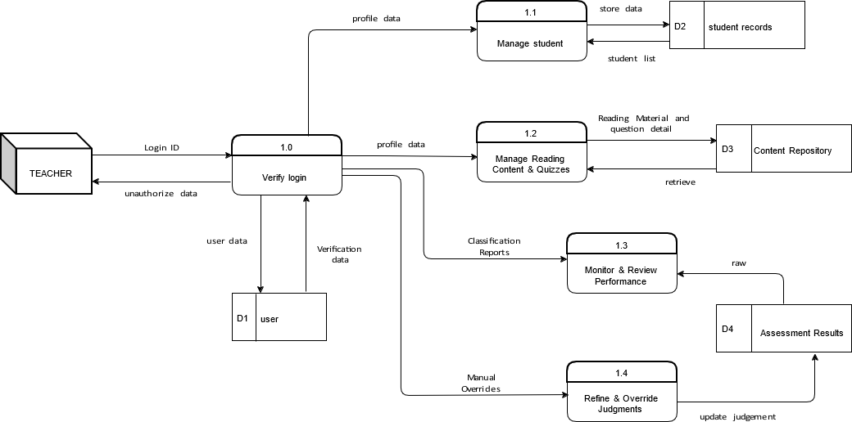
Figure 3.5.1

Part 1 of Data Flow Diagram of a Voice-based reading assessment system for enhancing the Aral reading program
Figure 3.5.1 shows the teacher-side administrative functions of the system into five specific sub-processes. This segment focuses on how data is managed and stored to facilitate the Aral Reading Program. The process begins with Process 1.0 (Verify Login), where the teacher's credentials are authenticated against the D1 (Users) data store. Once authorized, the teacher can engage in Process 1.1 (Manage Student Records), which involves adding or updating student information in D2 (Student Records). To populate the system with curriculum, Process 1.2 (Manage Content Repository) allows the teacher to upload and organize reading sets and questionnaires, which are then saved in D3 (Content Repository). The output phase is handled by Process 1.3 (Generate Performance Reports), which retrieves data from D4 (Assessment Results) to provide the teacher with detailed analytics on student progress.

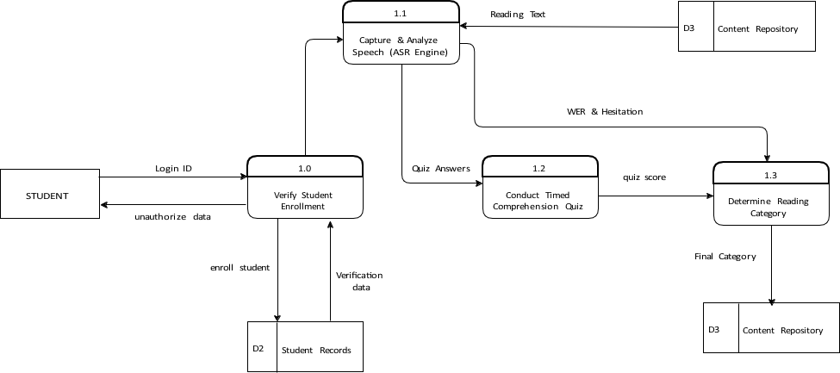

Finally, Process 1.4 (Refine Assessment Judgments) allows the teacher to review the automated ASR classifications and apply manual overrides if necessary, ensuring the accuracy of the final data stored in D4.
Figure 3.5.2

Part 2 of Data Flow Diagram of a Voice-based reading assessment system for enhancing the Aral reading program
For student-side illustrates the operational flow of the assessment from the perspective of the learner, The cycle starts with Process 1.0 (Verify Student Enrollment), where the system checks the student's ID against D2 (Student Records) to ensure they are registered in the program. Upon successful verification, Process 1.1 (Load Reading Material & Timer) retrieves the specific set assigned to the student from D3 (Content Repository) and initiates the assessment clock. The core technical function is performed by Process 1.2 (Analyze Speech), where the system utilizes an ASR engine (Whisper) to process the student's voice input. This process compares the audio against the reference text from D3 to calculate the Word Error Rate (WER), hesitation, and reading speed. Following the

reading phase, Process 1.3 (Manage Timed Questionnaire) presents the comprehension quiz and records student answers.
The final logical step is Process 1.3 (Calculate Reading Classification), which aggregates the fluency metrics from Process 1.2 and the quiz score from Process 1.3 to determine if the student is a Non-reader, Struggling, or Instructional reader. This final judgment is then recorded in D4 (Assessment Results).

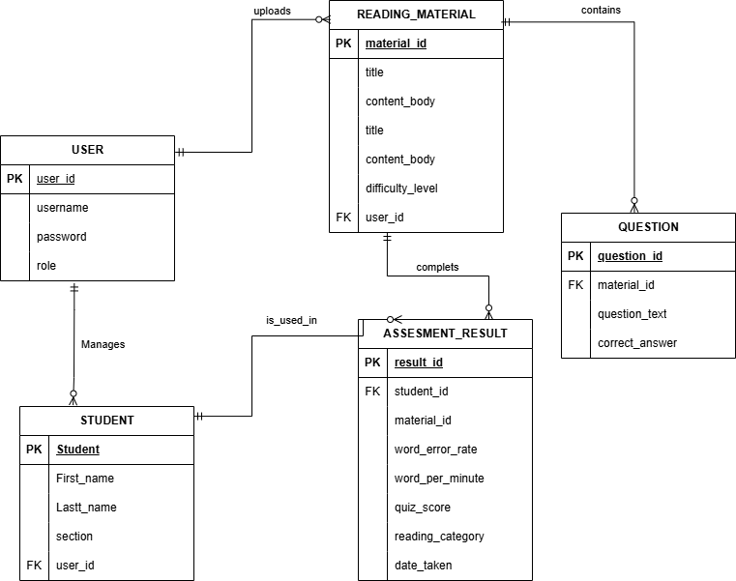
Figure 3.6

Entity Relationship Diagram of a Voice-based reading assessment system for enhancing the Aral reading program
The Entity Relationship Diagram (ERD) outlines the logical structure of the system's database, ensuring that data is stored in a normalized and relational format. The primary entity is the User, which represents the administrative or teaching staff and maintains a one-to-many relationship with the Student entity, as one teacher may manage multiple students. The User entity also manages the Reading Material entity, which serves as the parent for the Question entity. Each reading set contains multiple comprehension questions, establishing a one-to-

many relationship between the material and its associated quiz items. At the center of the system is the Assessment Result entity, which serves as an associative record linking a Student to a specific piece of Reading Material. This entity stores the critical metrics generated during a session, including the Word Error Rate (WER), Words Per Minute (WPM), and the final reading category. Because one student can take multiple assessments over time and one reading material can be assigned to many students, the relationships surrounding the Assessment Result ensure that every session is unique and traceable. This database design provides the necessary architecture to support the data flows described in the DFDs.

Phase 4: Testing

In this phase, the system was tested by selected students and teachers from Barcelonita Fishers School. The researchers scheduled testing sessions to evaluate the system’s performance in real scenarios. Students used the system to complete reading tasks using their computers, while teachers monitored the outputs. If an error occurred the researchers will fix the system and will schedule another test. Multiple testing cycles were conducted to ensure that the system is reliable, accurate, and user-friendly.

Phase 5: Evaluation

In this phase, the researchers evaluated the system’s overall performance and effectiveness. Feedback from teachers and students was gathered to assess its usability, accuracy, and functionality in supporting students’ reading skills, particularly in fluency, pronunciation, and comprehension. The results served as the basis for conclusions and recommendations for further system improvement.

NOTES

Larman, C., & Basili, V. R. (2003). Iterative and incremental development: A brief history. Computer, 36(6), 47–56. Retrieved from https://ieeexplore.ieee.org/document/1204375

Kumar, A., & Bhatia, P. (2014). Comparative analysis of SDLC models. International Journal of Advanced Research in Computer Science and Software Engineering, 4(6), 372–376. Retrieved from https://www.researchgate.net/publication/273885661_Comparative_Analy sis_of_SDLC_Models

